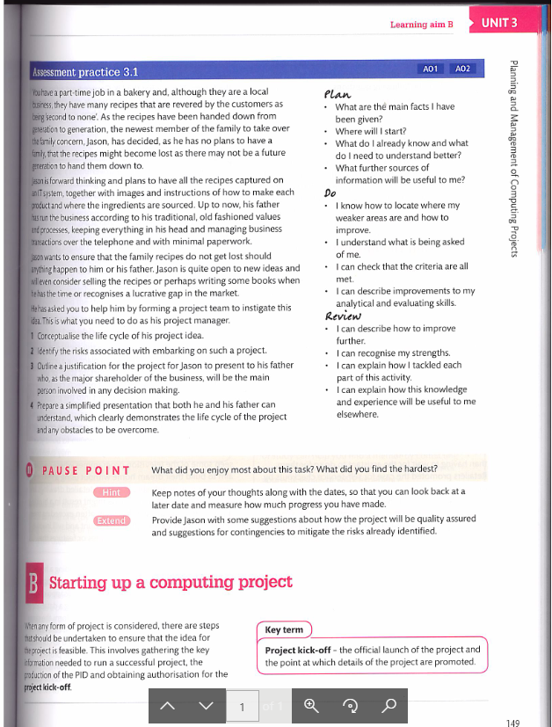

1 - conceptualise the life cycle of this project idea.

* Conception

The purpose of this system is to log instructions and pictures of Jason's bakery’s recipes so that in the eventuality that something untoward happens to him that they are not lost and can still be picked up by a future inheritor.

* Planning

f

* Implementation

f

* Closure

f

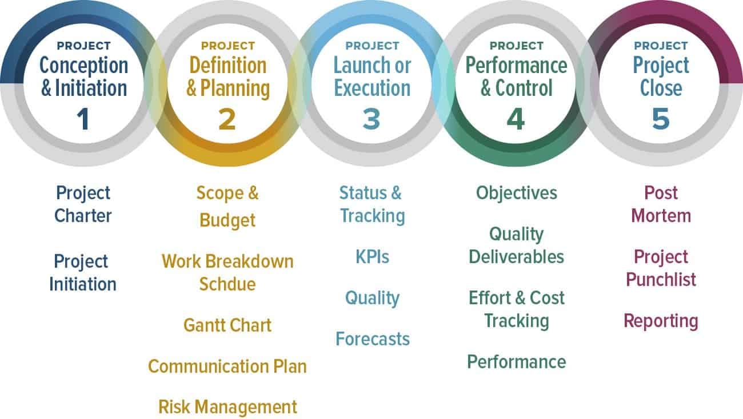

2 - Identify the risks associated with embarking on such a project.

The risks associated with embarking on a project such as this are that … family, budgets, timescales, “buy in” (make sure the dad is on board with it)

3 - Outline a justification for the project for Jason to present to his father who as the major stockholder of the business, will be the main person involved in any decision making.

Dear Jason’s father,

I am writing to inform you about the benefits to implementing an IT system to keep your bakeries recipes safe in the case that anything untoward should happen to you or your son.

As I am sure that you are aware, your practise of keeping the recipes in your head according to your traditional values is very risky, and I am sure that you will be hesitant to write down these recipes anywhere as they are your livelihood and you surely do not want them to be stolen by any of your competitors but I can assure you that the chance of this happening is close to none and in the case that you choose to use an IT system to keep track of your business you will definitely see that the pros outweigh the cons.

You will surely see a boost in efficiency around your workplace as you will not need to spend as much of your time making business choices in person and there is also no risk that you may forget the recipes or business deals that you have made. Now however low the risk of that happening is, it is always better to be on the safe side and take no chances of anything happening, especially when it comes to your own livelihood.

In the case that you choose to sell your recipes you will need to have them written down and this will save you quite a lot of hassle...

Kind regards, IT company

4 - Prepare a simplified presentation that both he and his father can understand, which clearly demonstrates the life cycle of the project and any obstacles to be overcome.

fgeswgews